**Example1  
  
Does not require any API key**. The **JSONPlaceholder** API used here is a free and open public API that doesn't need authentication or an API key.  
  
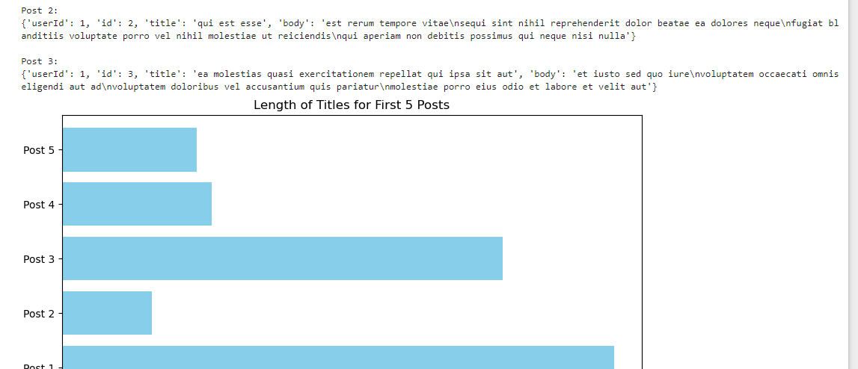

**Example 2**  
  
**API Access**: fetched trivia data using the Open Trivia Database API.

**Data Transformation**: transformed the data into a useful format (category, difficulty, question).

**Storage**: stored the data in an SQLite database.

**Fetching**: fetched a random trivia question.

**Visualization**: visualized the distribution of difficulty levels.

API Access: Open Trivia Database

Transform and Store the Data in SQLite

Fetch a Random Trivia Question

Creative Visualization: Difficulty Distribution

**Output & Creative Results**

1. **Random Trivia**: we got a random trivia question with its category and difficulty level displayed.
2. **Visualization**: seen a bar chart showing the distribution of trivia questions by difficulty (easy, medium, hard), which adds a fun, interactive element to analyzing the trivia dataset.